Kavya Gundala

02-01-2024

**Delta Lake Tables in Azure Data Bricks:**

* Delta Lake is an open-source storage layer that brings ACID transactions to Apache Spark and big data workloads. It is often used in conjunction with Azure Databricks, a cloud-based big data analytics platform built on Apache Spark.
* Delta Lake is fully compatible with Apache Spark APIs, and was developed for tight integration with Structured Streaming, allowing you to easily use a single copy of data for both batch and streaming operations and providing incremental processing at scale.
* Advantages of Delta Lake Tables:

1. ACID Transactions

2. Schema Evolution

3. Time Travel

4. Unified Batch and Streaming Processing

5. Optimizations for Query Performance

**Databricks:**

* Creating a data bricks resource

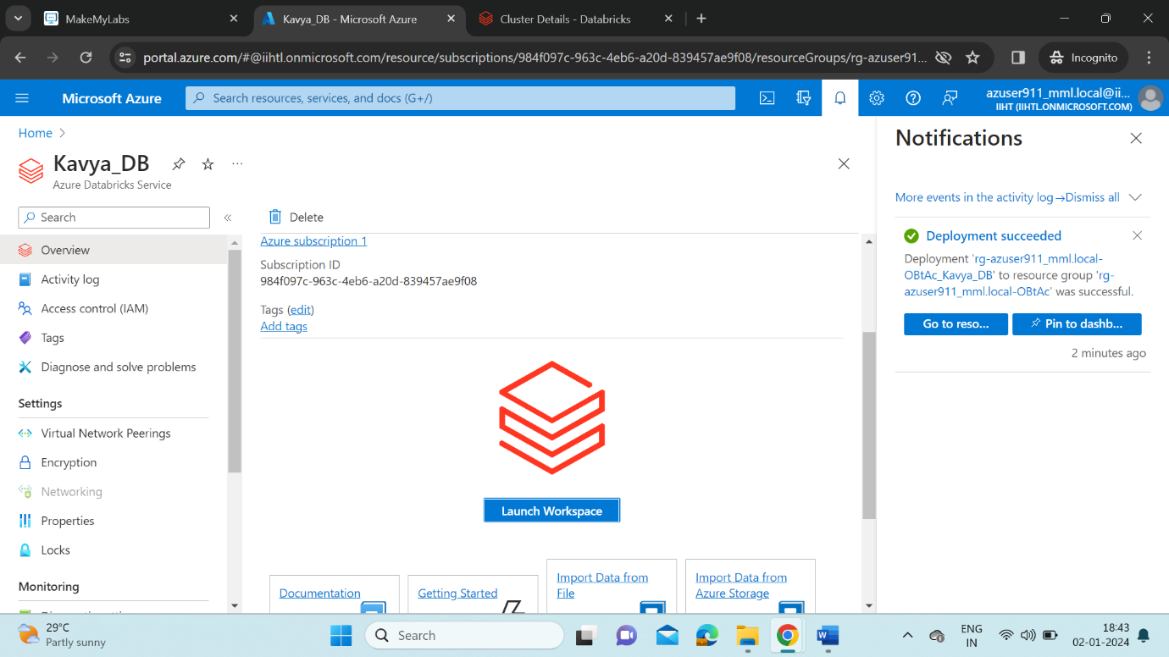

* Launch Workspace it redirects to Azure Databricks portal.
* Create a cluster named QuickStart.

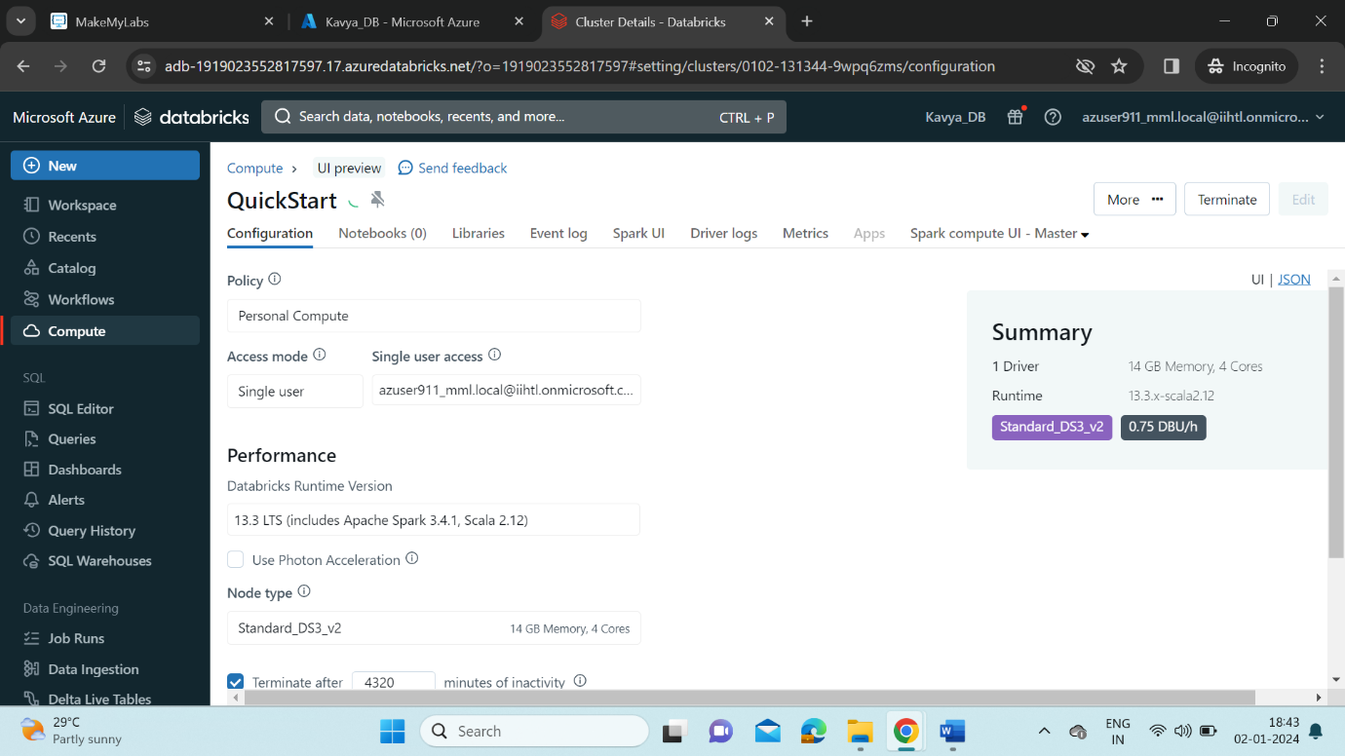

* Create a Notebook from New-> Notebook

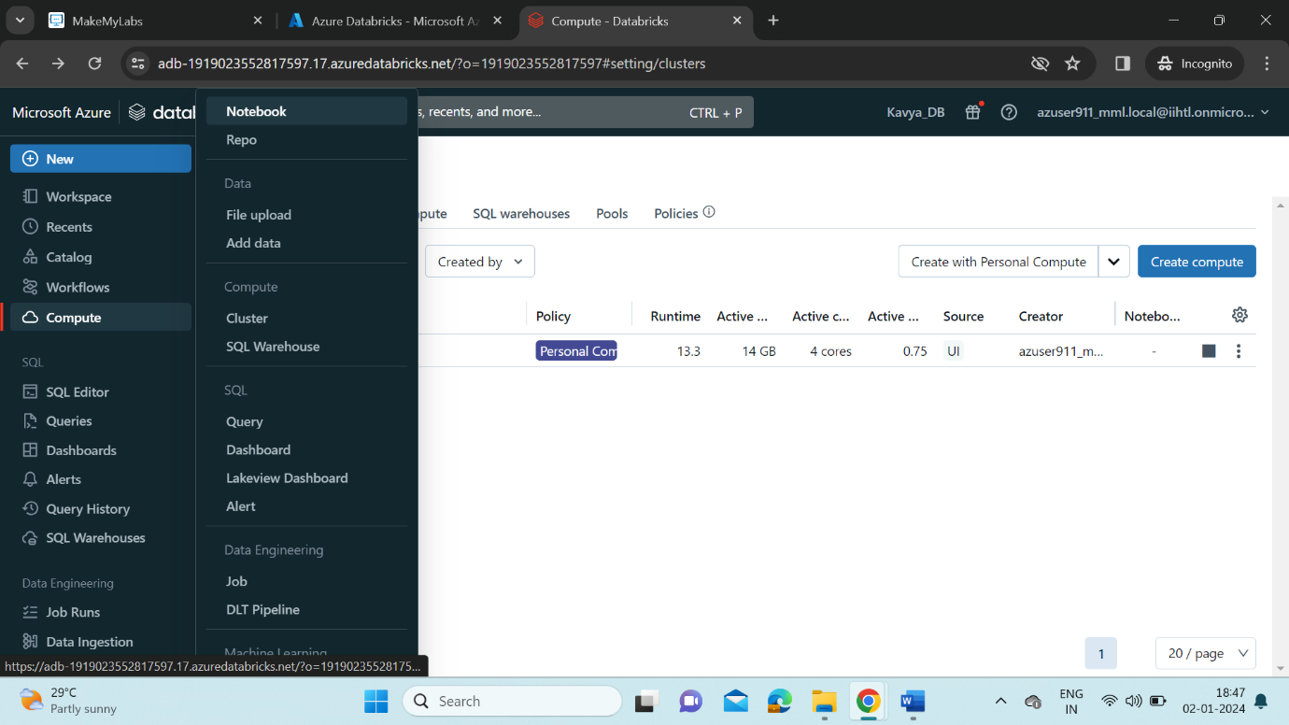

* Connect to QuickStart Cluster in the Menubar.

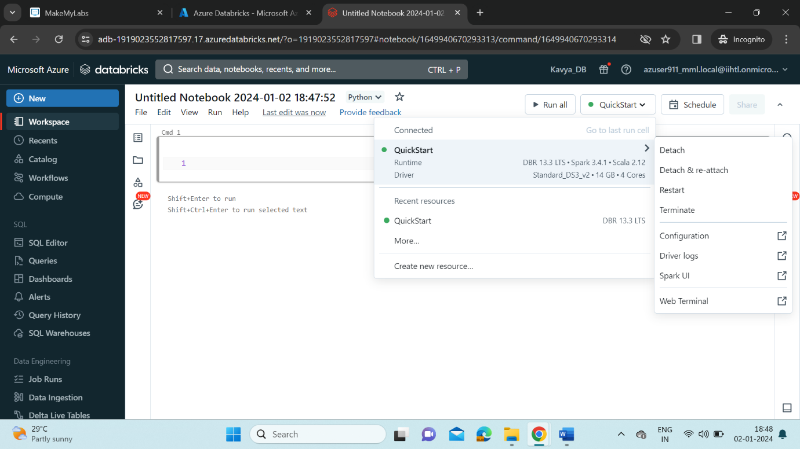

* Create a Python data frame in Notebook and run it.

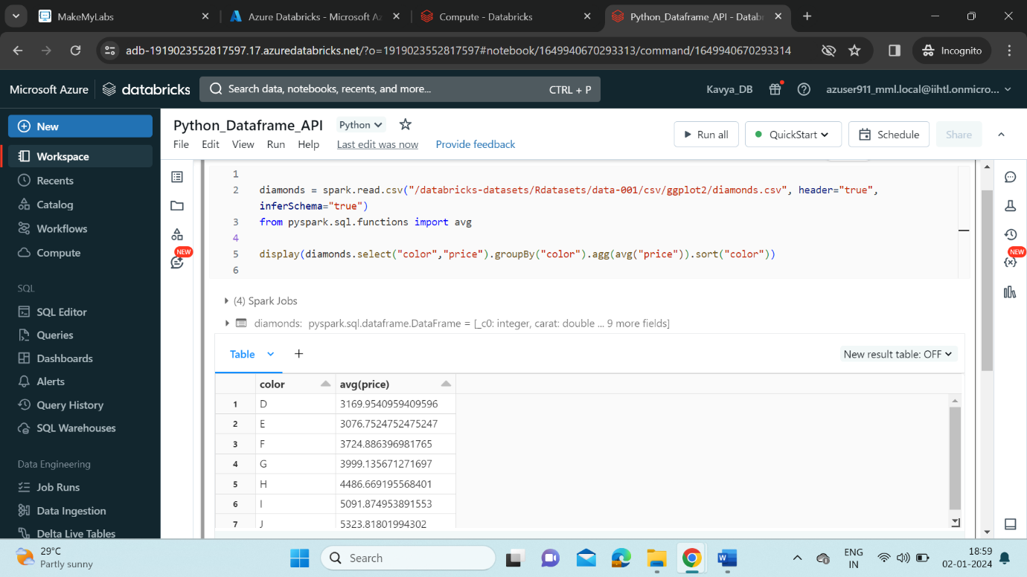

* Creating Data Lake tables in Azure Databricks.

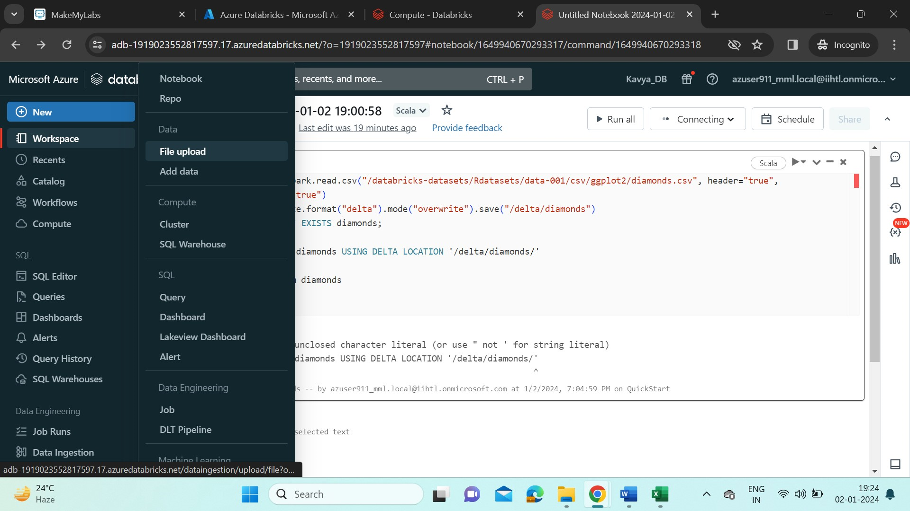

* Insert file into Azure Databricks.

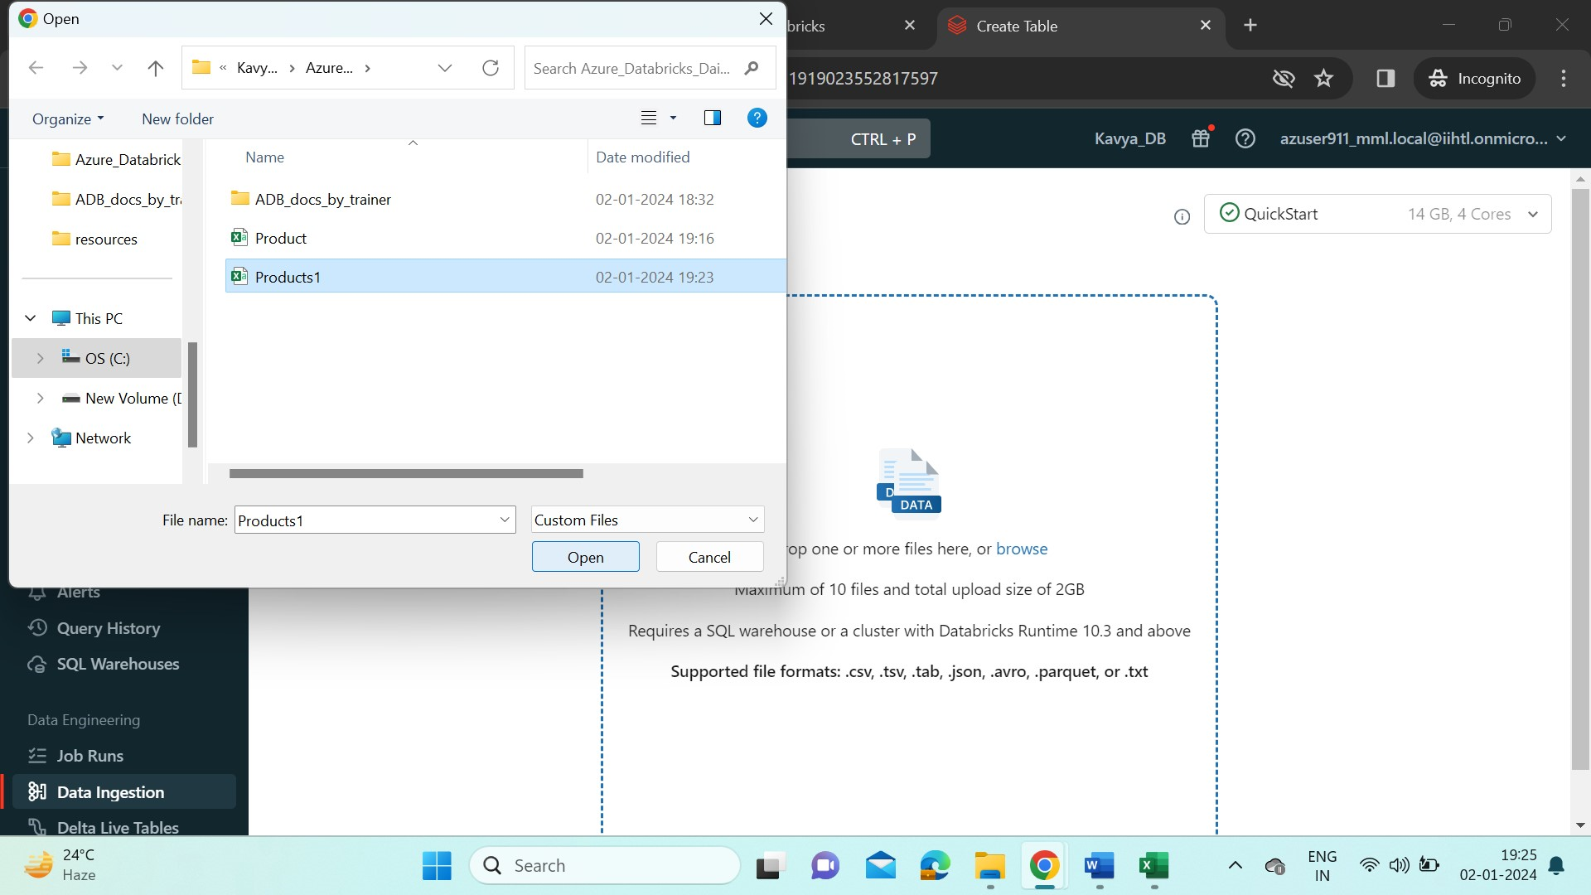

* Click on Open it is uploaded to the data bricks folder.

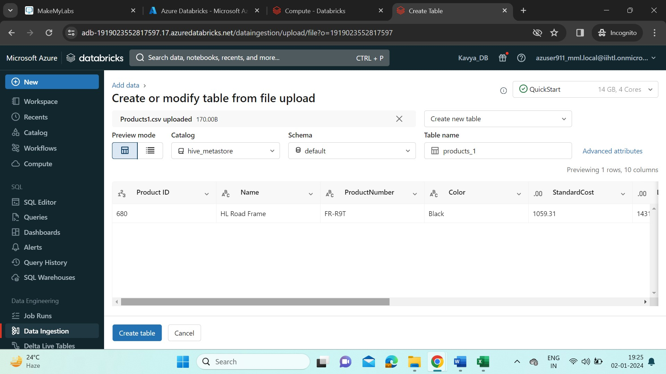

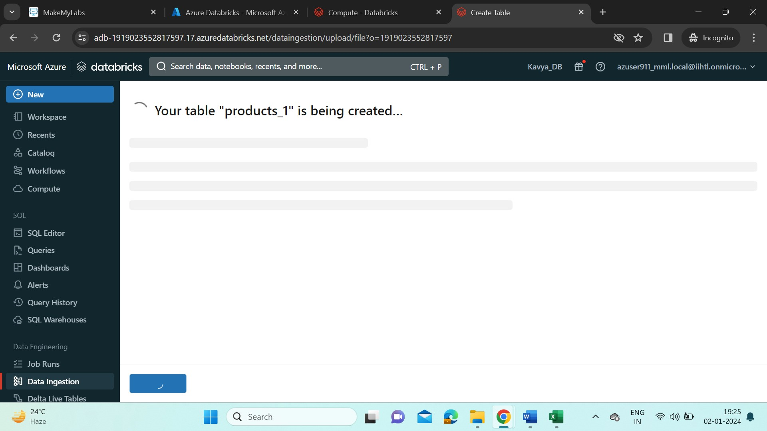

* The uploaded file is shown like this,

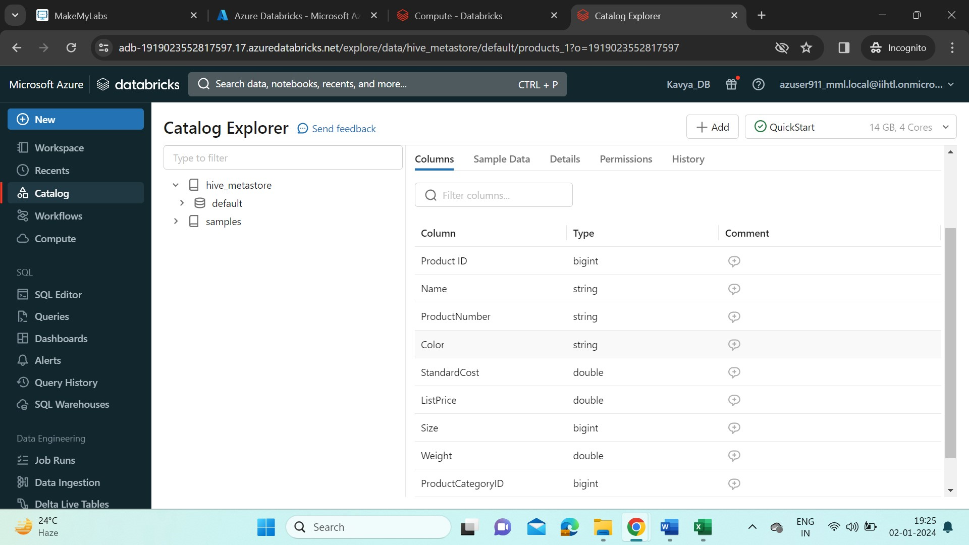

* Open the file and start executing commands.

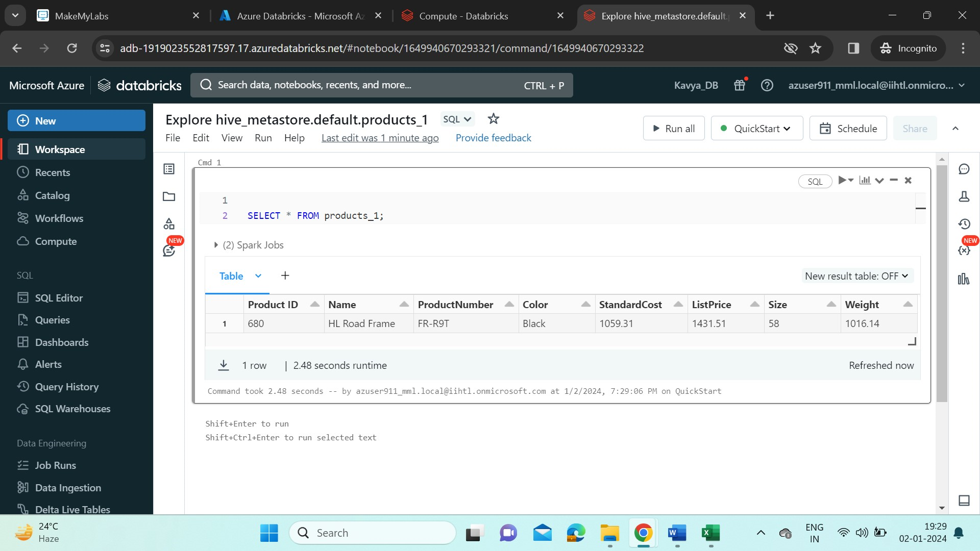

* When some of the commands cannot be executed on student version, we can try it on Community edition. Now we start executing Azure Delta Lake commands.
* Create a cluster “Kavya_cluster” in Databricks community edition.

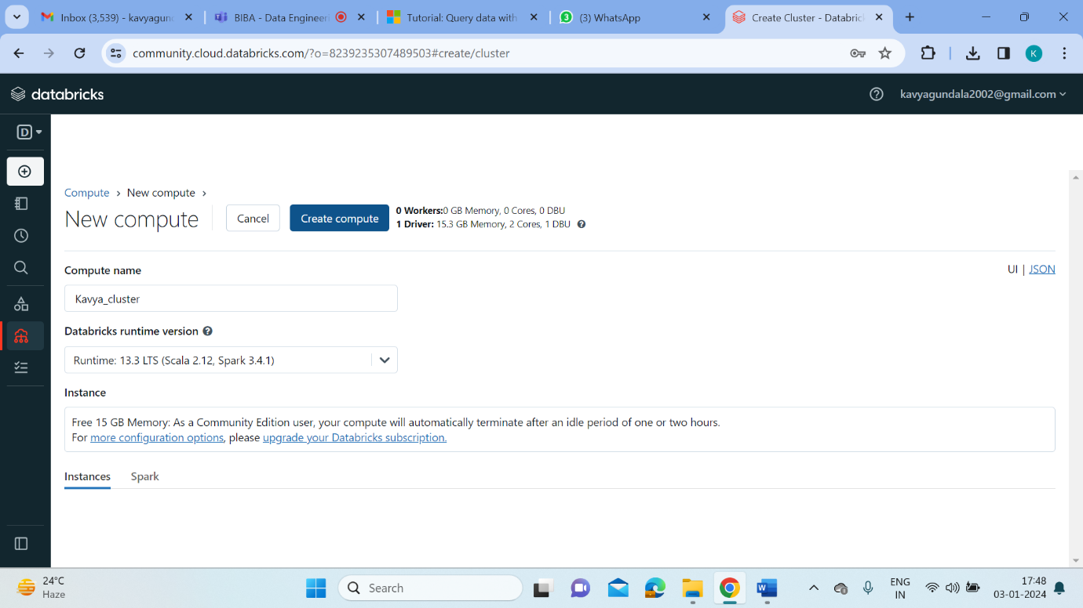

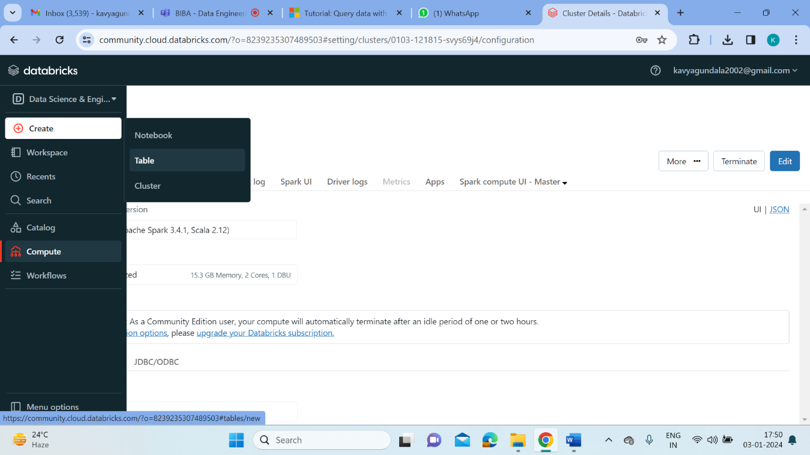

* Now start creating a table. Here, I’ve uploaded the Product_Details.csv file into the /FileStore/tables path. Select the “Kavya_cluster”. And now it will provide a Preview for the data in Product_Details.csv file.

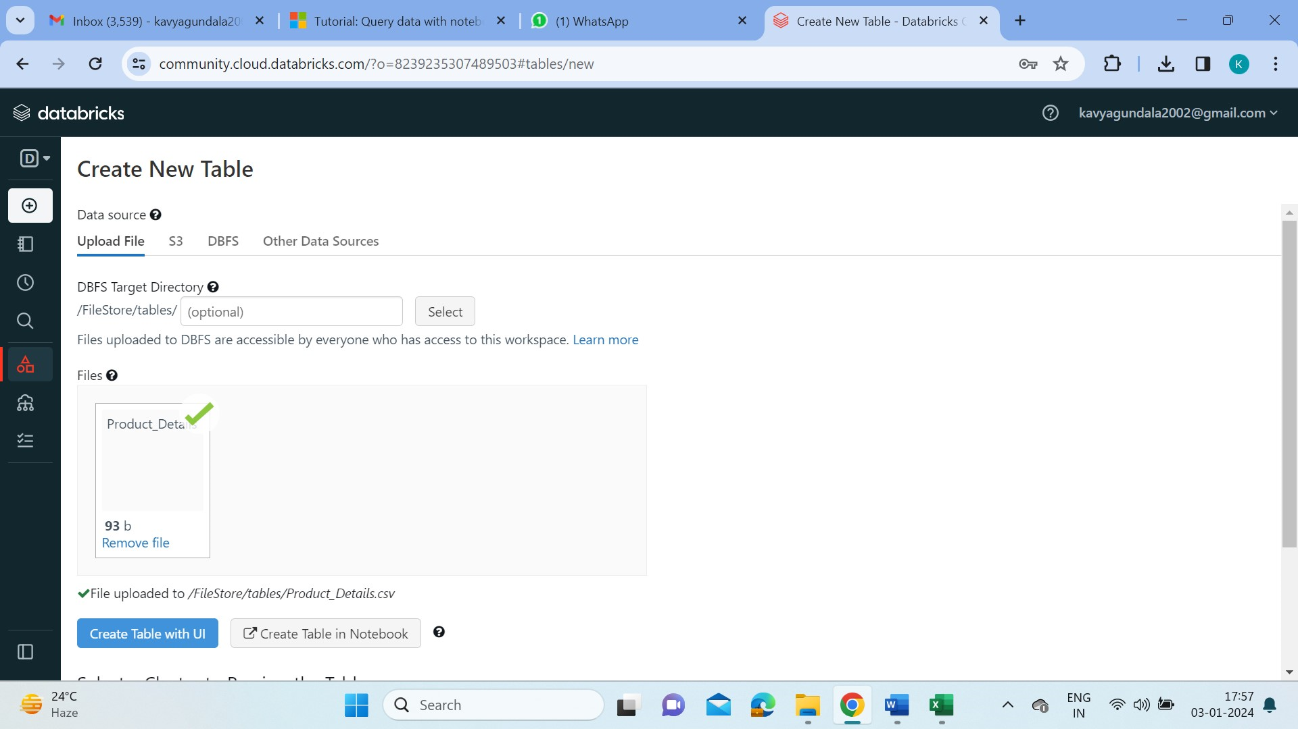

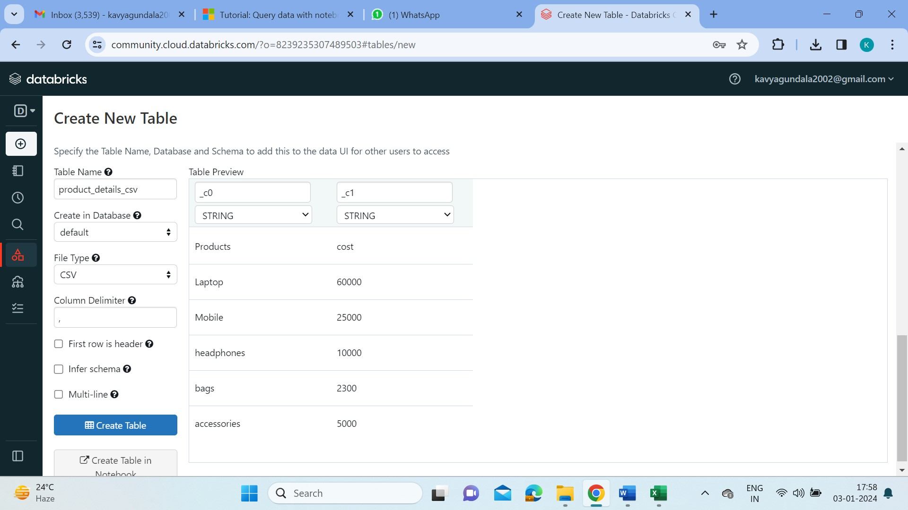

* We can load the uploaded file by specifying the path of it in FileStore. The language here used is Python.

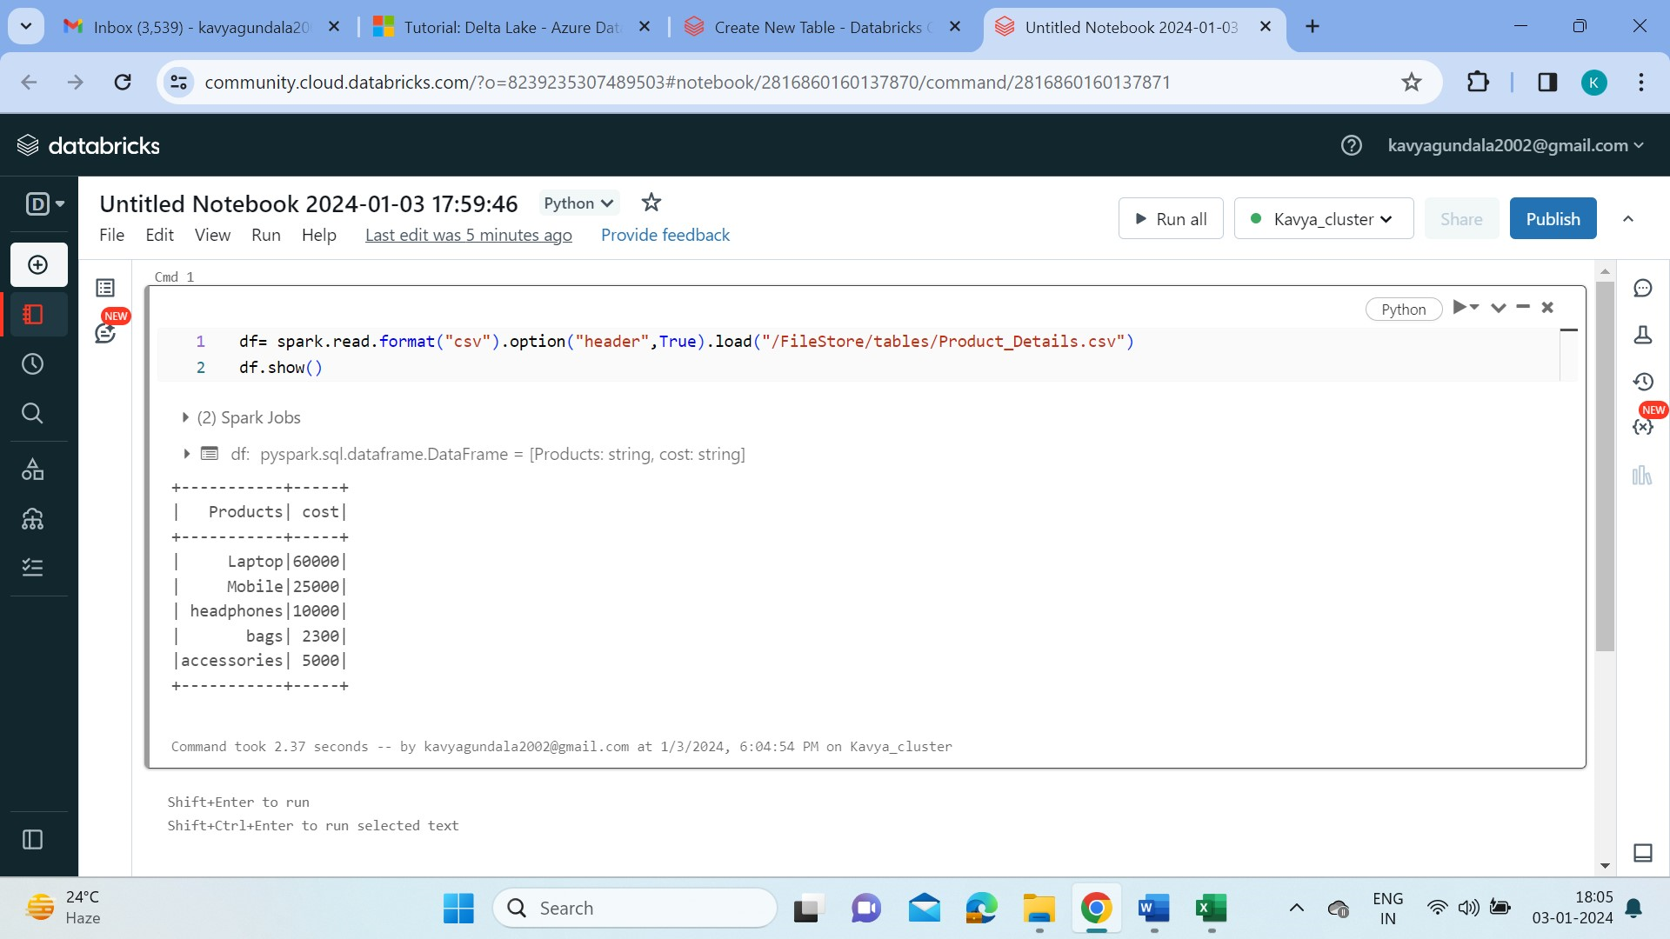

* Now we convert the dataframe into delta table as shown below.

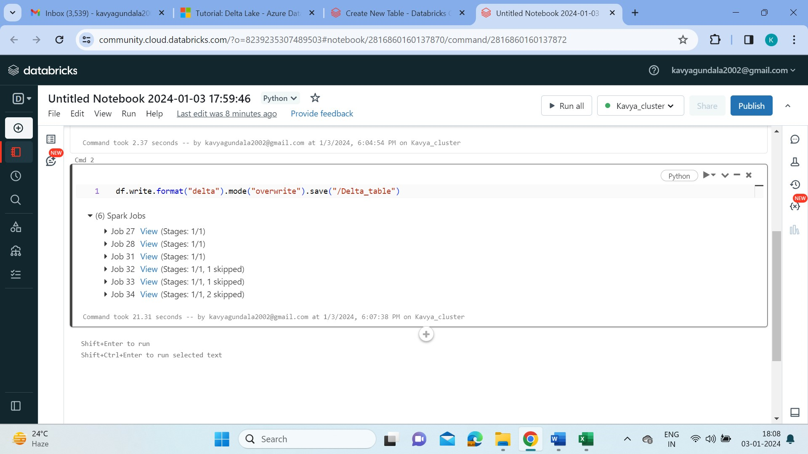

* We can display the data in the delta table using below command,

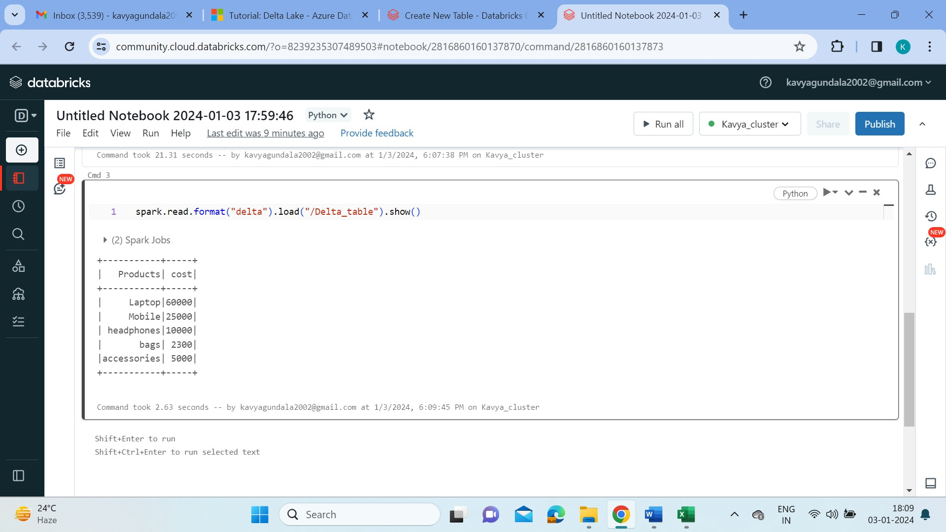

* We can also create temporary views for the delta table as below.



* We can locate the created temporary delta lake table like,

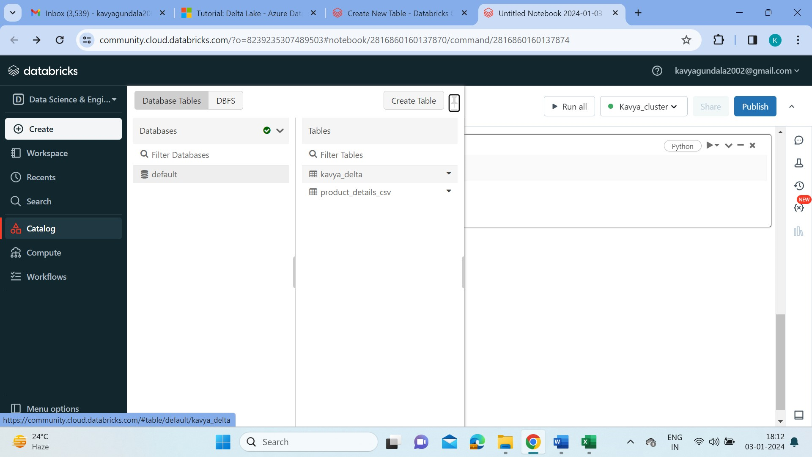

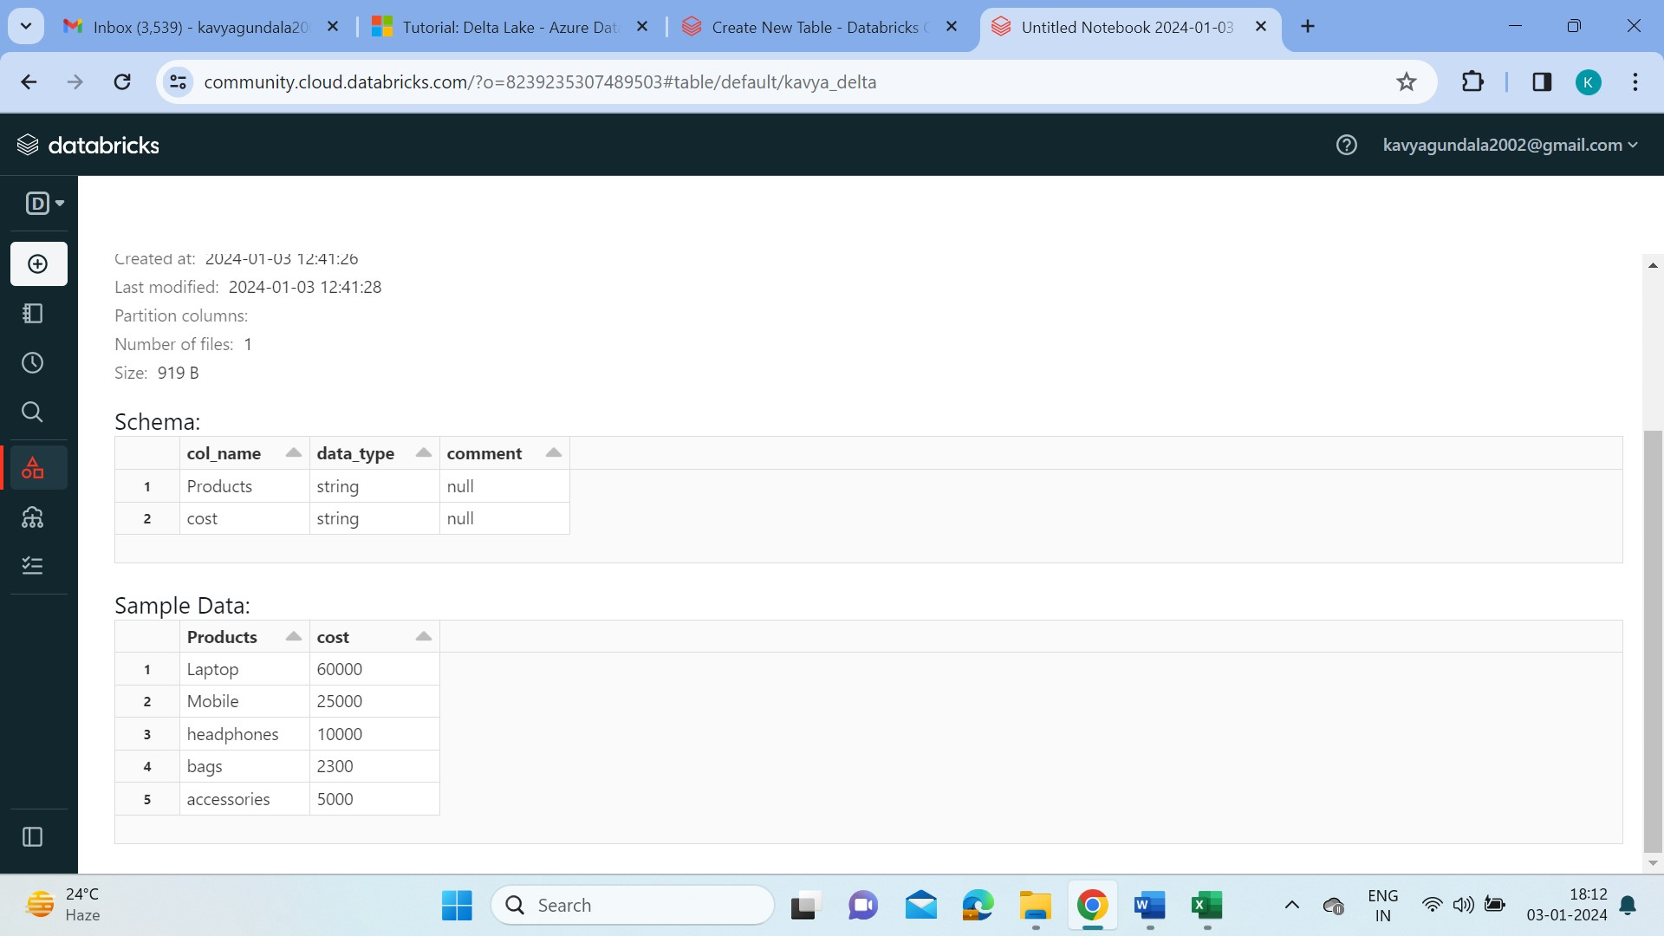

* We can also view the history of the table like below,

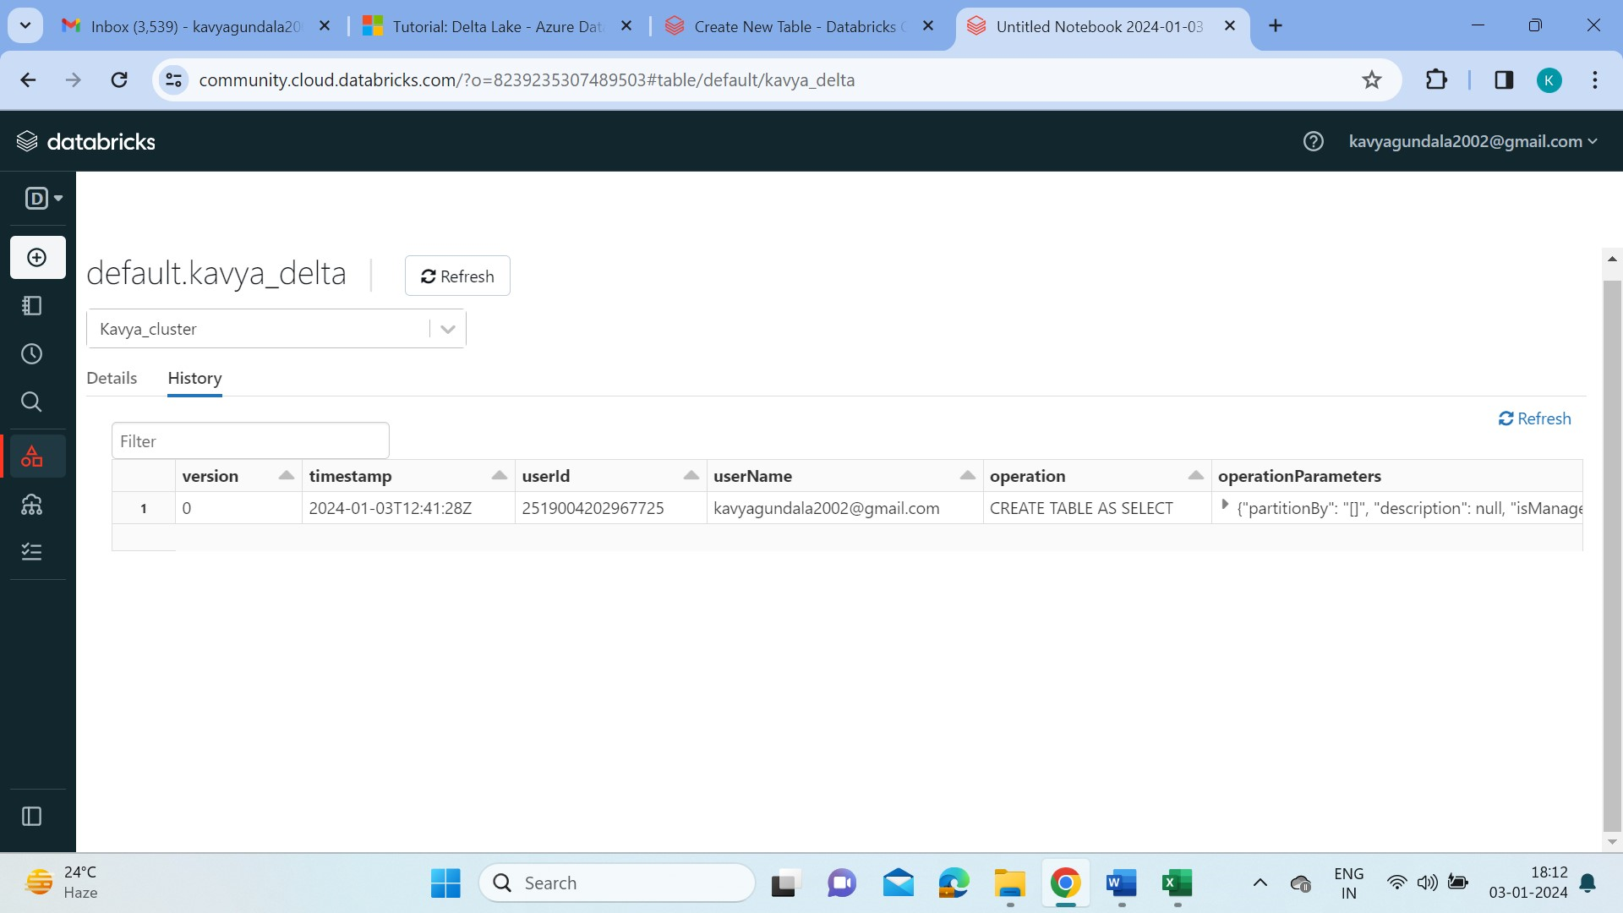

* Now we run some SQL commands on the delta lake table,

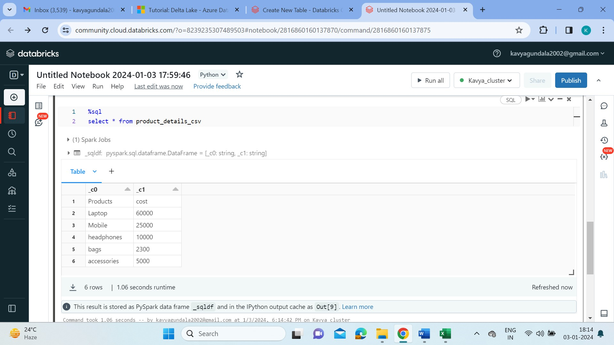

* We can also Visualize the data by clicking on ‘+’ and choose Visualization . Here I’ve visualized Bar chart and line chart.

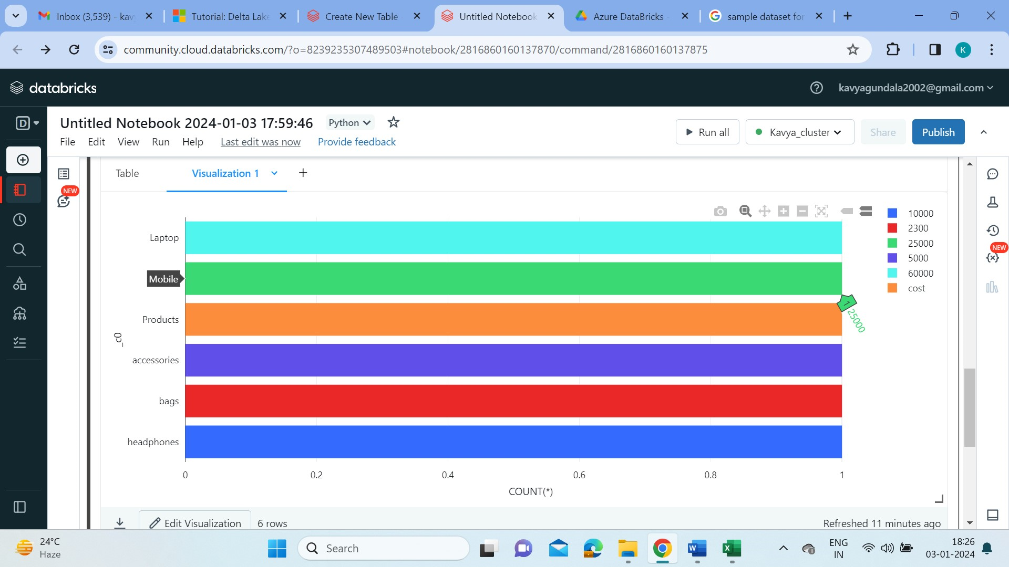

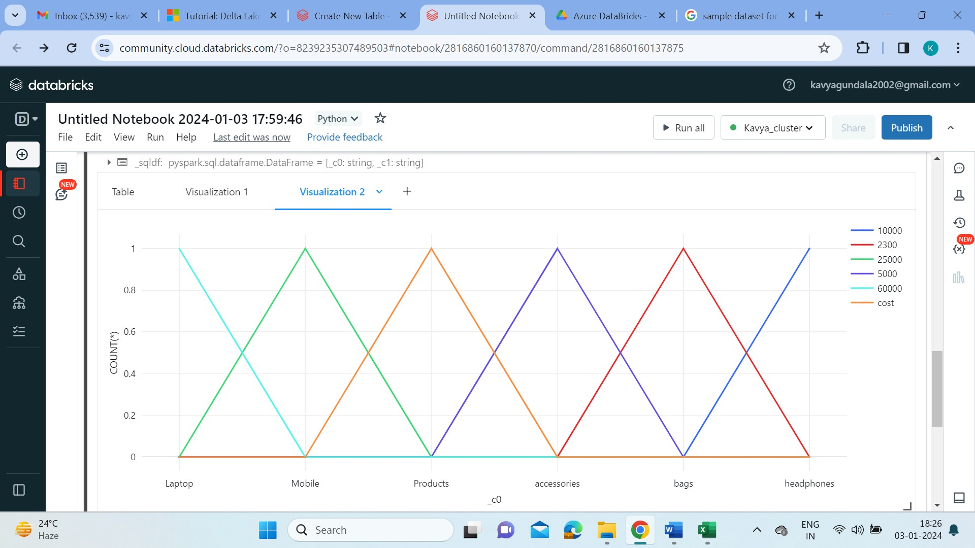

**Data Engineering Projects:**

* Projects in Data Engineering need to dealt with large amounts of data in efficient way. For that we need efficient technologies and tools to have a best product. Data engineering plays a pivotal role in the vast data ecosystem by collecting, transforming, and delivering data essential for analytics, reporting, and machine learning.
* Data engineers are responsible for analyzing and interpreting research results, then using those results to build new tools and systems. The unstructured data is taken and transformed into a format so that it is useful and understandable that other technologies can be used.
* The below are some technologies and resources that are mostly used by data engineers to provide best results.

Technologies to be used in Projects:

* PySpark - PySpark is the Python API for Apache Spark, an open source, distributed computing framework and set of libraries for real-time, large-scale data processing. With PySpark, we can write Python and SQL-like commands to manipulate and analyze data in a distributed processing environment. PySpark allows them to work with a familiar language on large-scale distributed datasets.
* Spark SQL - Spark SQL is Apache Spark's module for working with structured data. It provides Integrated, Uniform Data access, Standard Connectivity to work with data.
* Python - Python is a high-level, general-purpose programming language. It supports multiple programming paradigms, including structured, object-oriented and functional. Python can be used in Data engineering for its features like easy to use, simple, efficient.

Azure Resources to be used in Projects:

* Delta Lake: A data lake is a single, centralized repository where you can store all your data, both structured and unstructured.
* Azure Databricks: Azure Databricks provides tools that help you connect your sources of data to one platform to process, store, share, analyze, model, and monetize datasets with solutions from BI to generative AI.
* Azure Data Factory: Data Factory provides a data integration and transformation layer that works across your digital transformation initiatives. Azure Data Factory (ADF) is responsible for the execution of Azure Databricks notebooks as well as monitoring them.
* Azure Data Lake Storage Gen2 : A data lake is a single, centralized repository where you can store all your data, both structured and unstructured. Azure Data Lake Storage is a cloud-based, enterprise data lake solution. It's engineered to store massive amounts of data in any format, and to facilitate big data analytical workloads. The data is imported and stored in Azure Data Lake Container.